Analyze the Data

Team: Voting
26th Amendment  Section 1: The right of citizens of the United States, who are eighteen years of age or older, to vote shall not be denied or abridged by the United States or by any State on account of age.  The Constitution of the United States  Background:  The 26th Amendment was ratified on July 1, 1971. This amendment lowered the voting age from 21, and extended the right to vote in federal elections to all Americans aged 18 and older. Passage of the 26th Amendment was a result of 18-year-olds being drafted to fight in the Vietnam War but not holding the power to vote. The motto was, “Old enough to fight, old enough to vote!” | 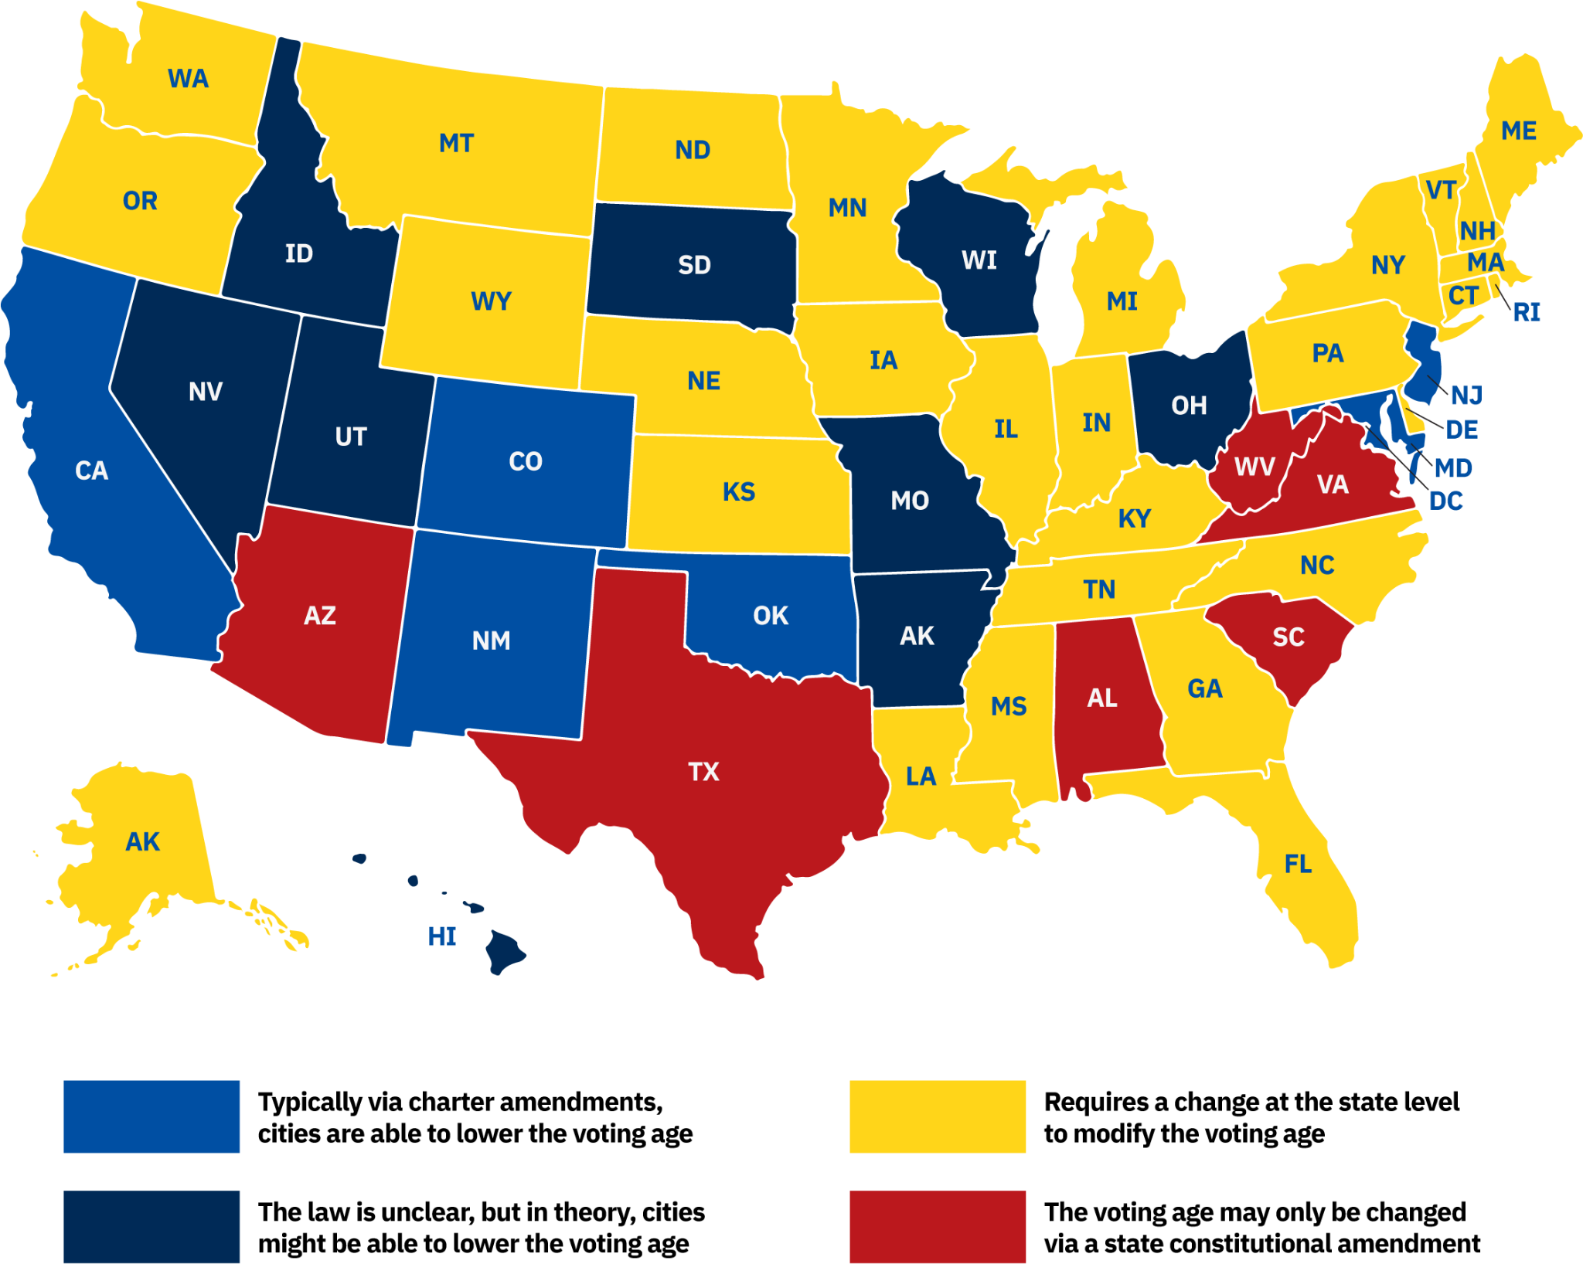
Map of Legal Feasibility of City Campaigns to Lower the Voting Age in Local Elections
Source: Young Voices at the Ballot Box: Amplifying Youth Activism to Lower the Voting Age in 2020 and Beyond [page 22] - vote16usa.org

Team: Driver’s License
Driving in the U.S.  Each state has the authority to establish its own traffic laws and issue driving licenses. Speed limits, driving age, and driver’s education requirements vary from state to state. Most states require drivers to have vehicle insurance. One commonality is that traffic is required to keep to the right, known as a right-hand traffic pattern. Another rule in all states is the requirement to wear a seatbelt. All states prohibit drunk driving, and drivers are required to stop for school buses with flashing red lights in all states. | 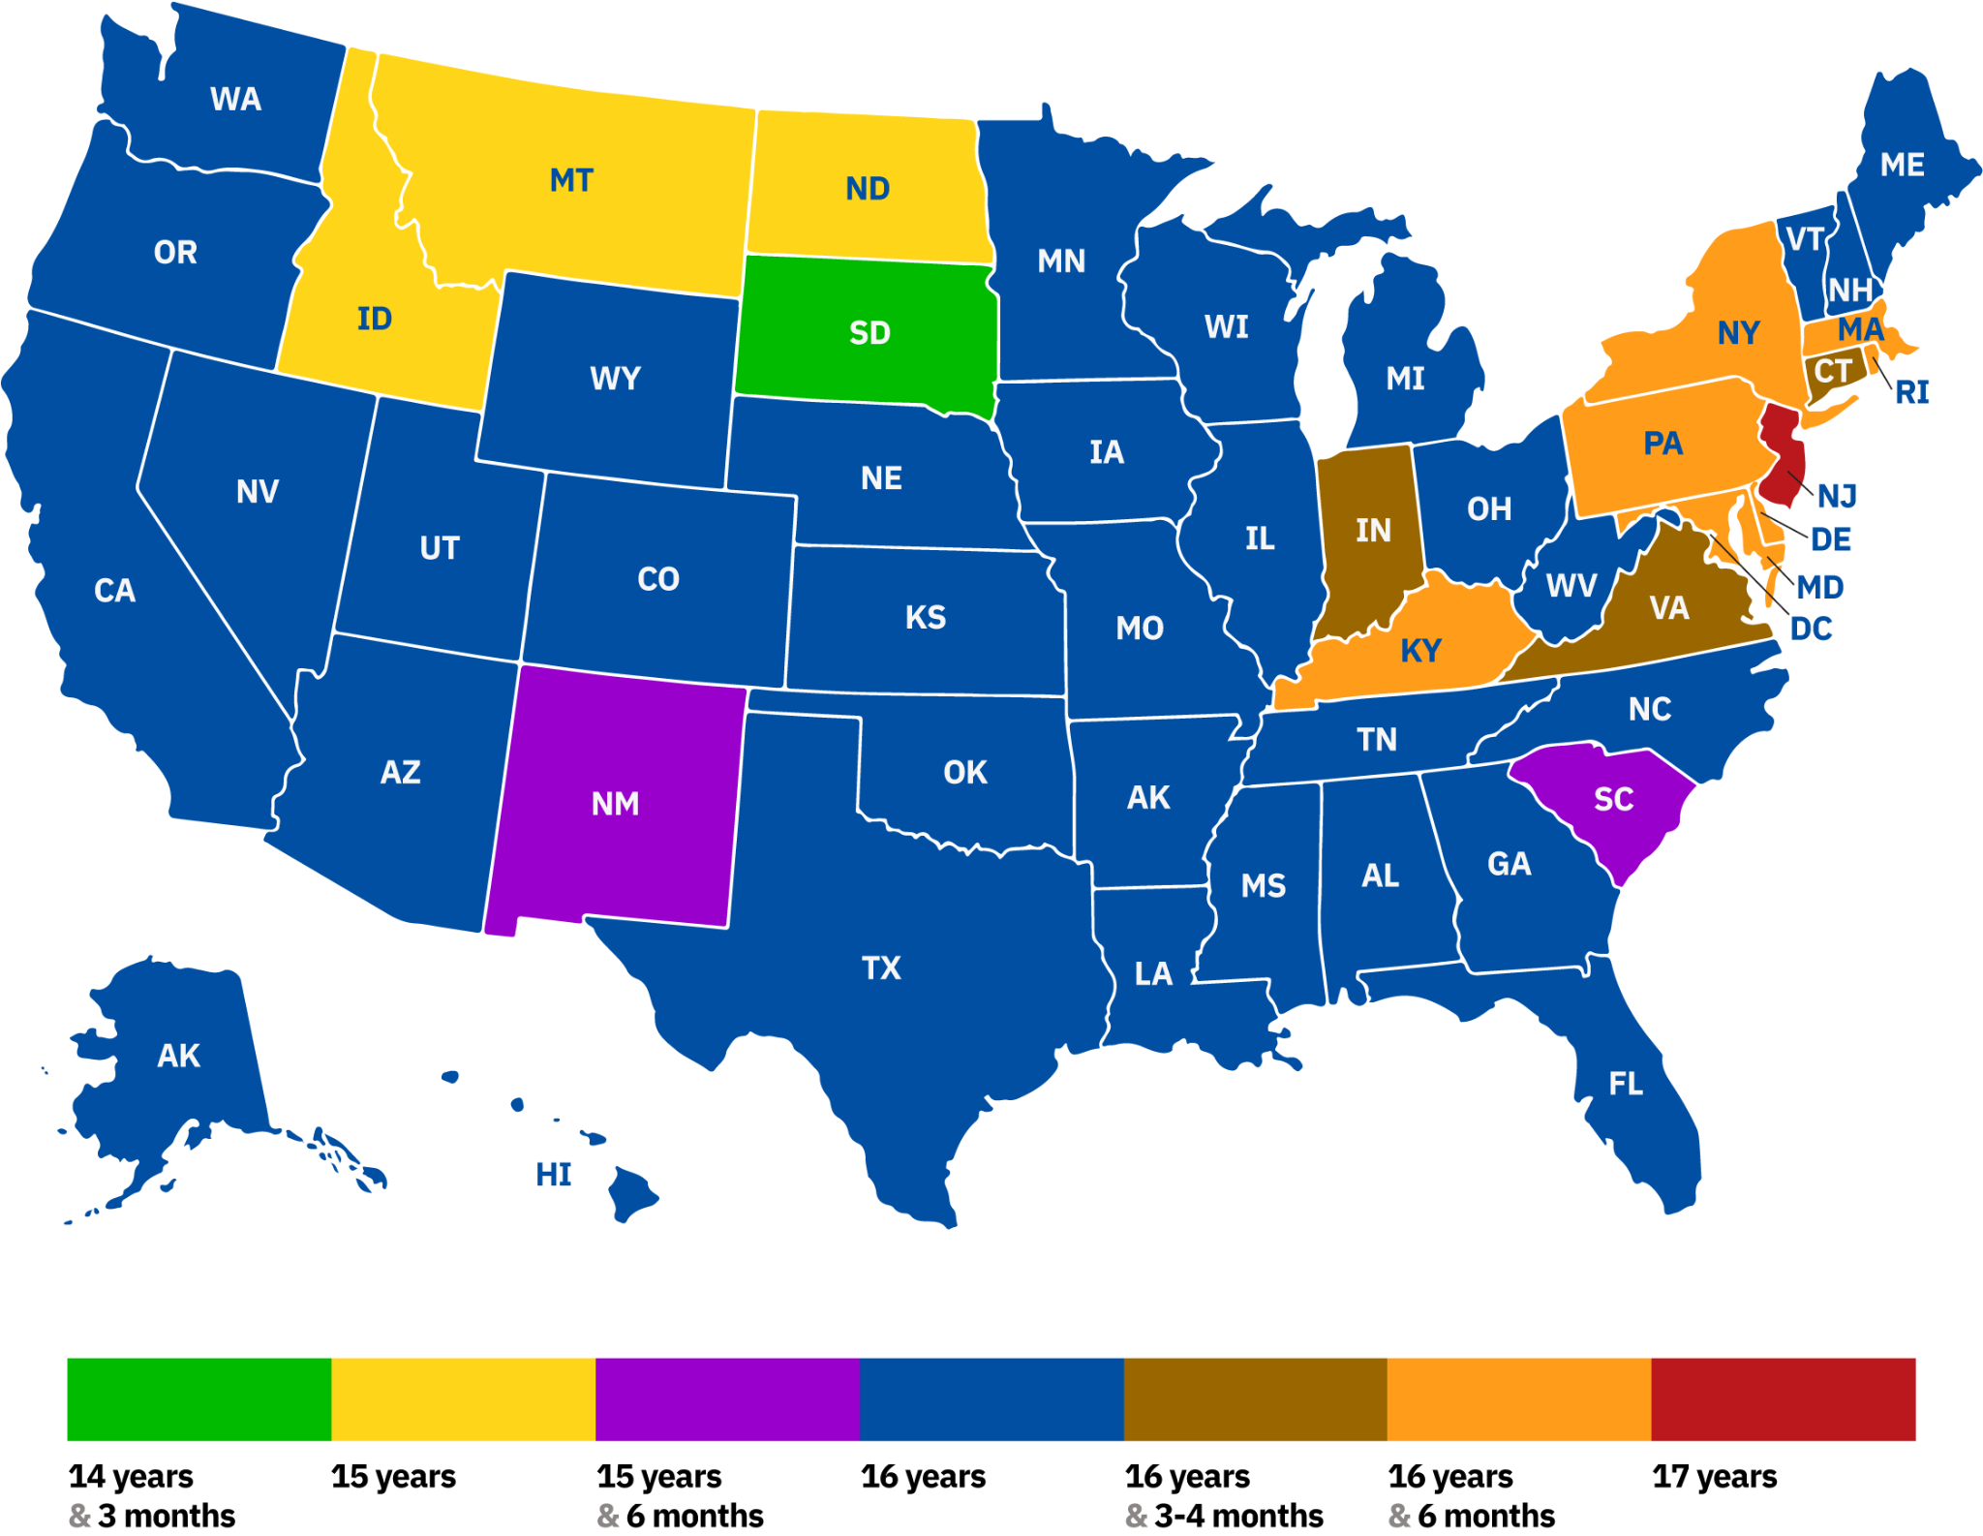
Map: Age at Which a Driver
May Obtain a Driver's License
Source: Wikimedia Commons

Team: Civic Education
Civics Graduation Requirement  Education is primarily the responsibility of the state and local governments, and there is no national civics graduation requirement for U.S. students. It is states and local communities, as well as public and private organizations of all kinds, that establish schools, develop curricula, and determine requirements for enrollment and graduation. The federal government does play a role in protecting students’ rights as the equal protection clause of the 14th Amendment specifies that a state may not “deny to any person within its jurisdiction the equal protection of the laws.” Additionally, in the Brown v. Board of Education of Topeka decision, the Supreme Court ruled that “separate but equal” facilities are inherently unequal and segregation of public education is unconstitutional. The federal government plays a supporting role to local and state education authorities. One way is through federal funding provided to states and local school districts. | 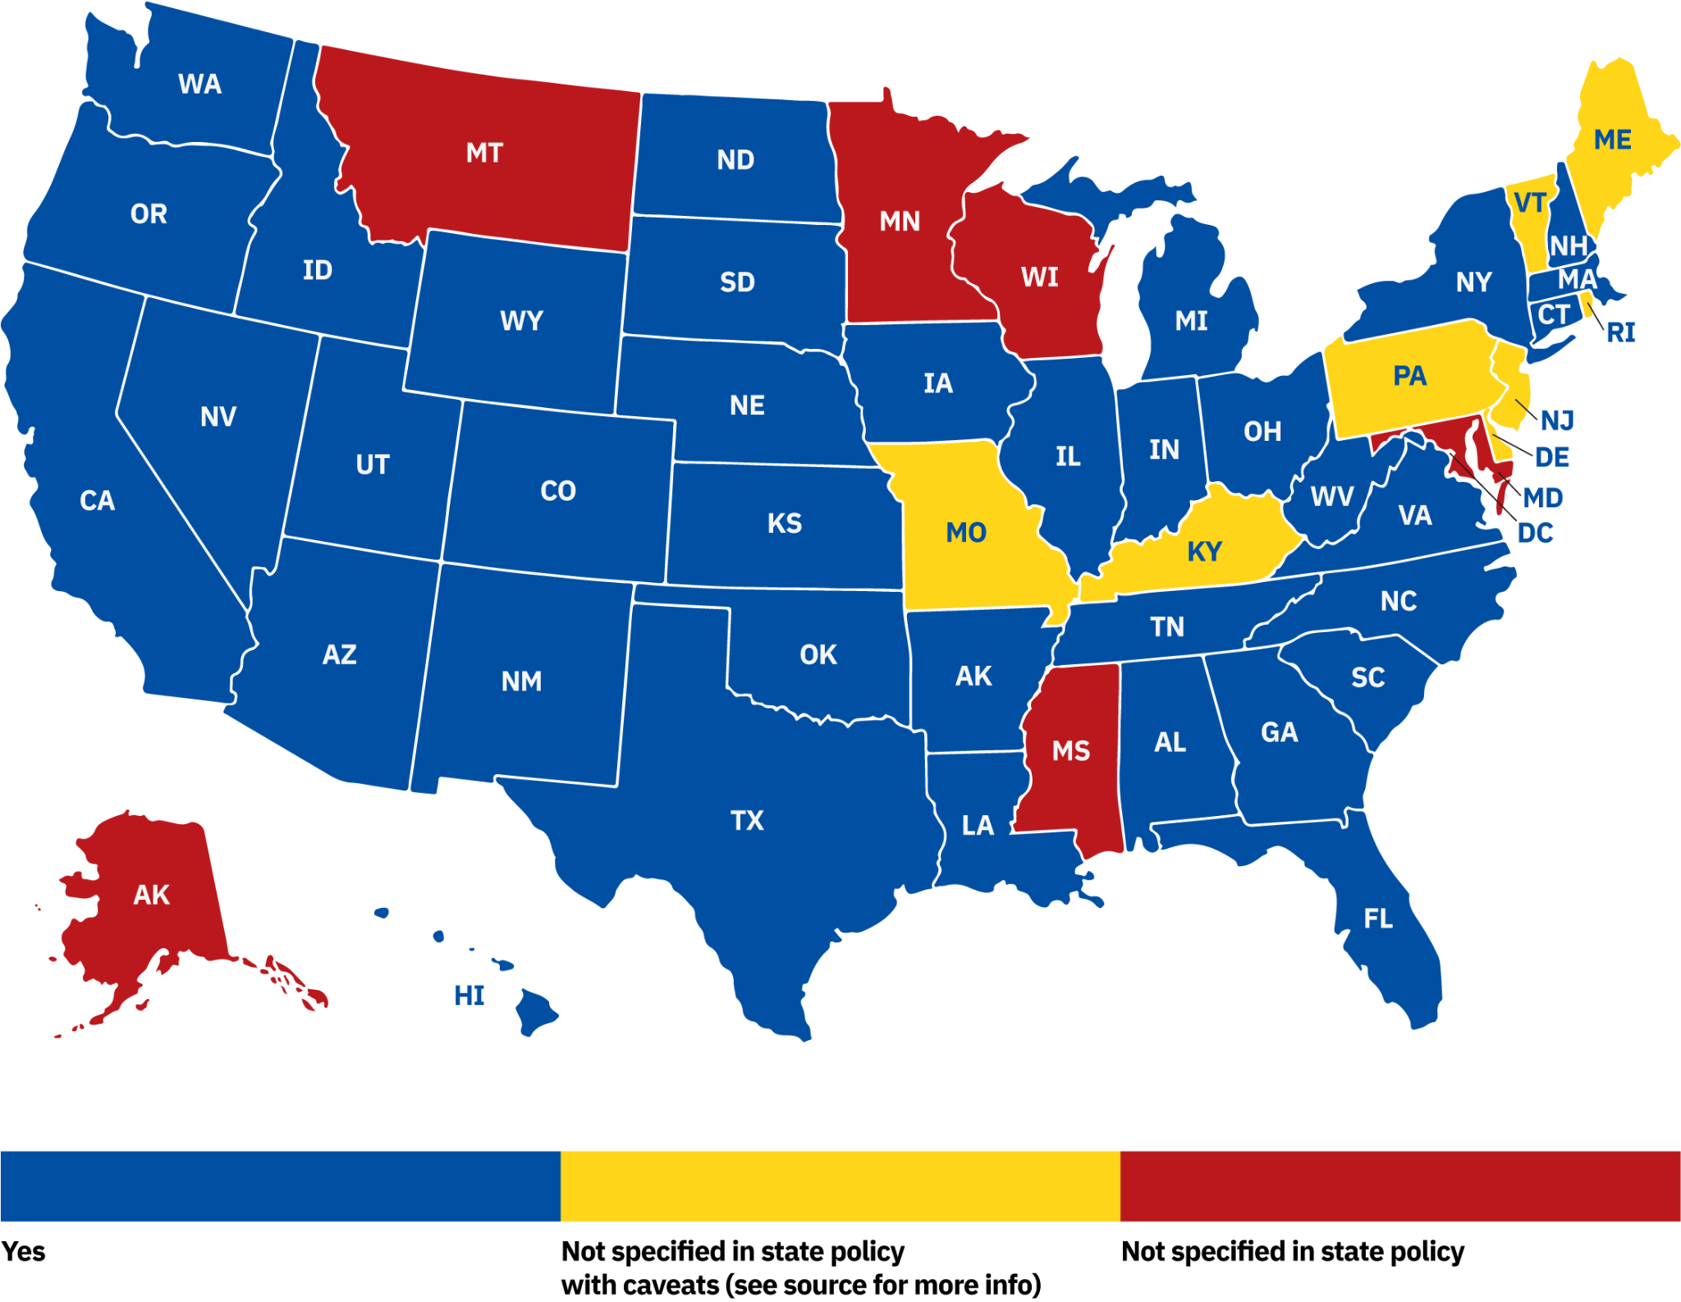
Map: States Requiring Civics Credits
to Graduate High School in 2023
Source: Education Commission of the States

