Paideia Seminar
Civil Dialogue Organizer

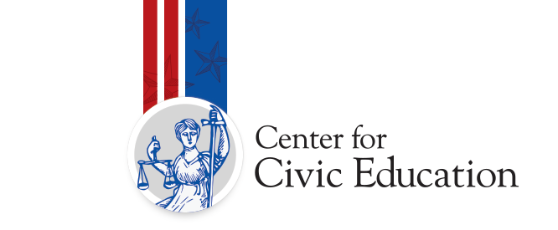
Seminar Topic: Paideia Seminar: McCulloch v. Maryland, 1819

Inquiry Question: Does the national government hold too much power?

Before Seminar
My personal goal for this seminar is the following: (Circle your goal.)
- To speak at least three times  - To refer to the text  - To ask a question | - To speak out of uncertainty  - To build on others’ comments  - Other
Our class goal for this seminar is the following: (Circle the class goal.)
- To focus on ideas and values embedded in the text  - To invite everyone to share their ideas  - To remember that one person speaks at a time | - To keep an open mind  - To use one another’s names  - Other

During Seminar
Use this space to record your ideas and wonderings as you listen and participate in our civil dialogue.

After the Seminar
Consider your experience with the seminar activity we just completed. Rate yourself and our class on the success in accomplishing our goals using the following scale:
3 = Nailed It! | 2 = Getting There | 1 = A Goal for Next Time

Goals for Inquiry Learning | Your Rating | Your Reasoning
My personal goal: | # | I gave this ranking because…
Our class goal: | # | I gave this ranking because…

What Else Do You Think?
One positive outcome of today’s seminar is…

One way to improve for our next seminar is to…

New ideas that my classmates and I now have include…

Things I still wonder about include…

