Equal Protection Timeline
1868 |  | 1954 |  | 1996
 | 1927 |  | 1967 |  | 2015
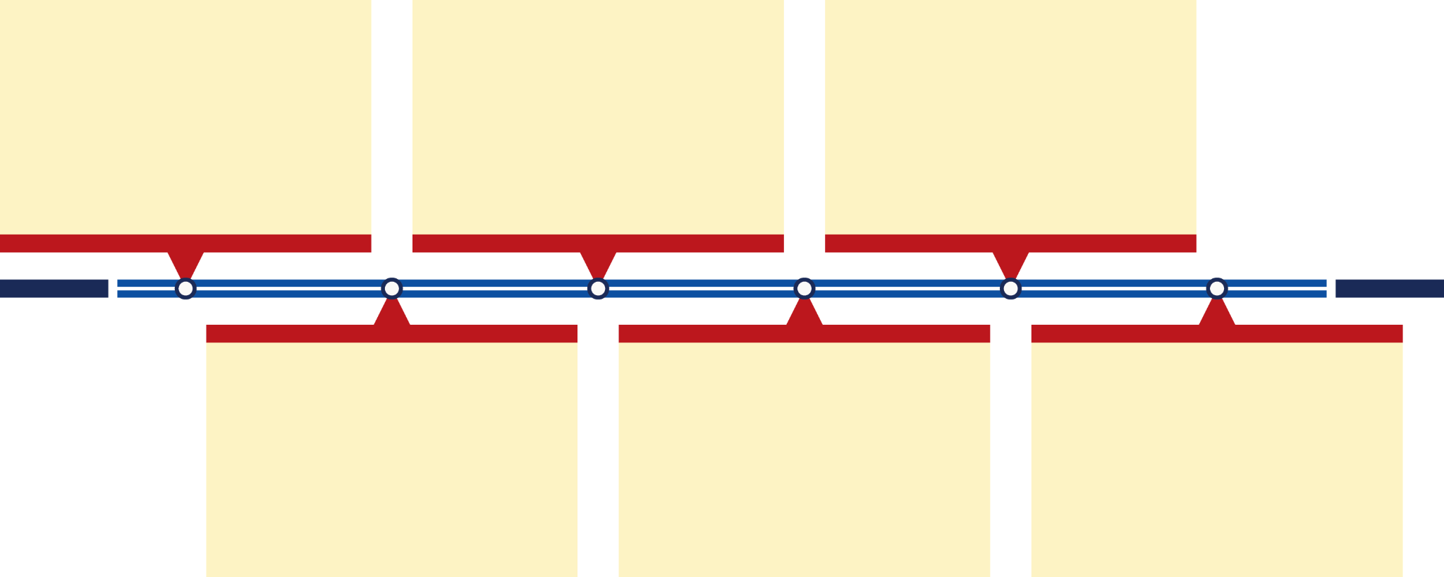

Use evidence from your timeline, your case study, and our civic conversation to answer our inquiry question:
“Does everyone have equal protection today?”

