What Is the Electoral College?

Annotation Station
❍ Circle words you don’t know, and take a moment to find the definition.
Highlight in YELLOW phrases that confuse you. Use context clues to try and figure out their meaning.
Highlight in BLUE items you find most important.
✩ Star the items that make you wonder and wish to explore further.

The Electoral College is a process, not a place. The Framers established it in the Constitution in part as a compromise between the election of the president by a vote of Congress and the election of the president by a popular vote of qualified citizens.

What is the process?

The Electoral College process consists of the selection of the electors, the meeting of the electors where they vote for president and vice president, and the counting of the electoral votes by Congress.

How many electors are there? How are they distributed among the states?

The Electoral College consists of 538 electors. A majority of 270 electoral votes is required to elect the president. Your state has the same number of electors as it does members in its congressional delegation: one for each member in the House of Representatives plus two senators.

The District of Columbia is allocated three electors and treated like a state for purposes of the Electoral College under the 23rd Amendment of the Constitution. For this reason, in the following discussion, the word “state” also refers to the District of Columbia, and “executive” to the state governors and the mayor of the District of Columbia.

How are my electors chosen? What are their qualifications? How do they decide who to vote for?

Each candidate running for president in your state has their own group of electors (known as a slate). The slates are generally chosen by the candidate’s political party in your state, but state laws vary on how the electors are selected and what their responsibilities are.

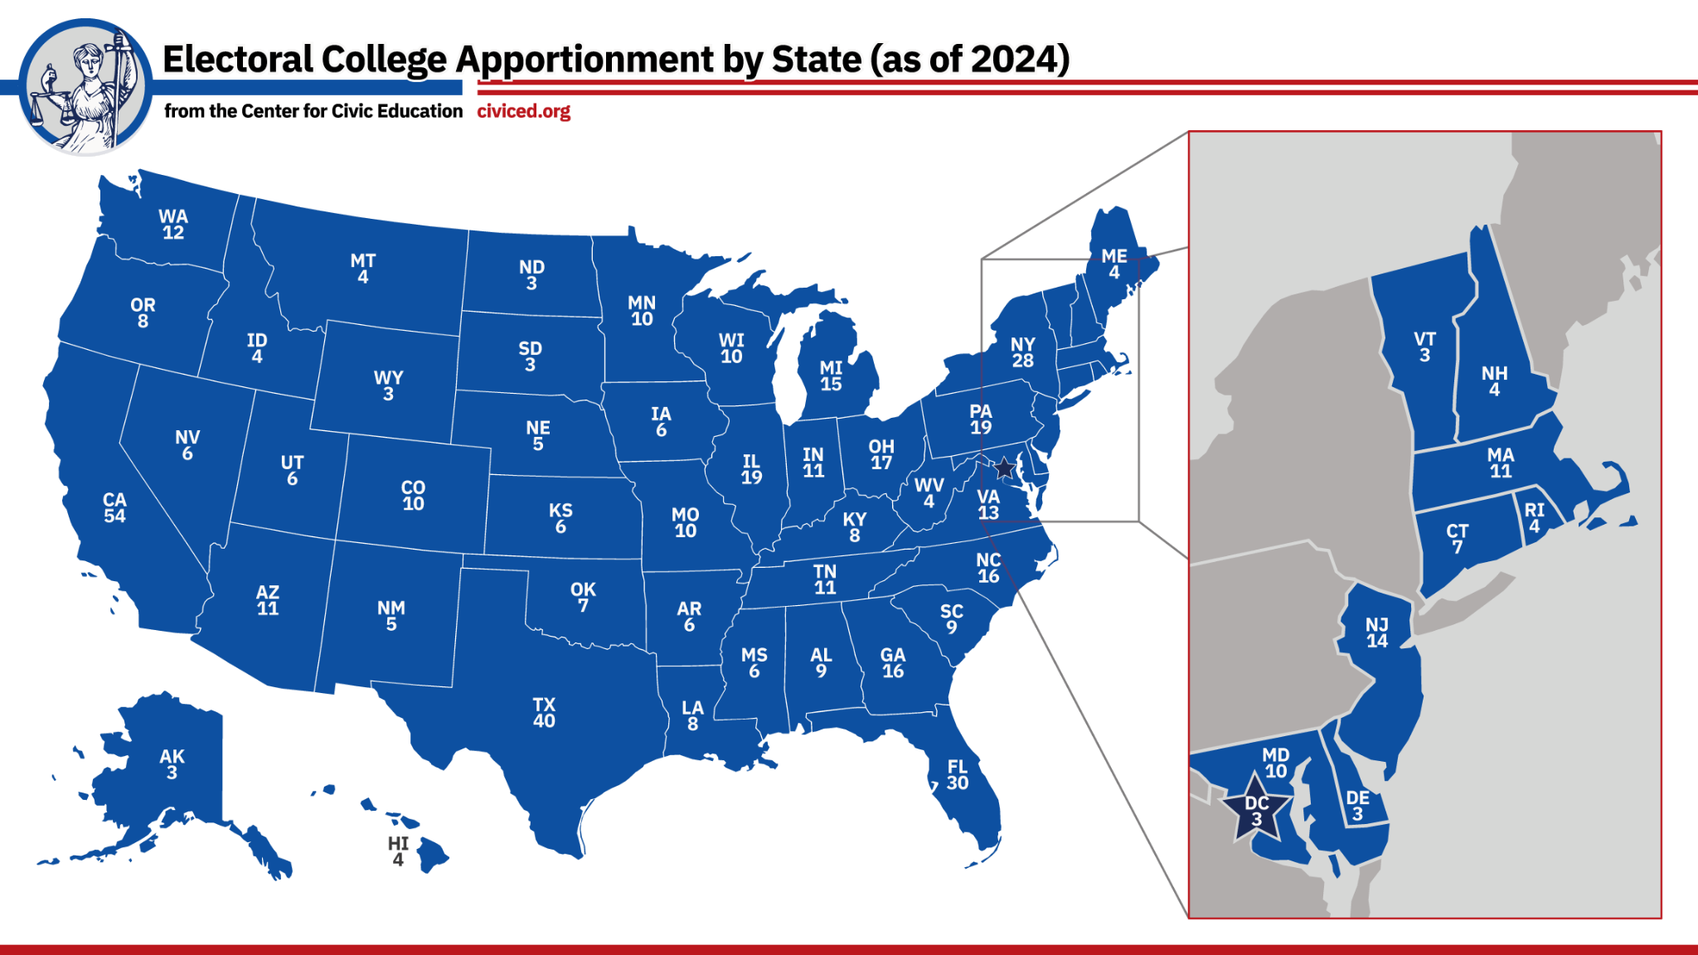
Apportionment totals taken from Wikimedia Commons

What happens in the general election? Why should I vote?

The general election is held every four years on the Tuesday after the first Monday in November. When you vote for a presidential candidate, you are actually voting for your candidate’s preferred electors.

Most states have a “winner-take-all” system that awards all electors to the presidential candidate who wins the state’s popular vote.

What happens after the general election?

After the general election, your state’s executive prepares a Certificate of Ascertainment listing the names of all the individuals on the slates for each candidate. The Certificate of Ascertainment also lists the number of votes each individual received and shows which individuals were appointed as your state’s electors. Your state’s Certificate of Ascertainment is sent to the National Archives as part of the official records of the presidential election.

The meeting of the electors takes place on the first Tuesday after the second Wednesday in December after the general election. The electors meet in their respective states, where they cast their votes for president and vice president on separate ballots. Your state’s electors’ votes are recorded on a Certificate of Vote, which is prepared at the meeting by the electors. Your state’s Certificate of Vote is sent to Congress, where the votes are counted, and to the National Archives and Records Administration, as part of the official records of the presidential election.

Each state’s electoral votes are counted in a joint session of Congress on January 6 in the year following the meeting of the electors. Members of the House and Senate meet in the House Chamber to conduct the official count of electoral votes. The vice president of the United States, as president of the Senate, presides over the count in a strictly ministerial manner and announces the results of the vote. The president of the Senate then declares which persons, if any, have been elected president and vice president of the United States.

The president-elect takes the oath of office and is sworn in as president of the United States on January 20 the year following the general election.

Source: Adapted from the National Archives

