Life of an Enslaved Man

Annotation Station
❍ Circle words you don’t know, and take a moment to find the definition.
Highlight in YELLOW phrases that confuse you. Use context clues to try and figure out their meaning.
Highlight in RED examples of the dangers or restrictions faced by the individuals.
Highlight in GREEN examples of rights and freedoms enjoyed by the individuals.
✩ Star the items that make you wonder and wish to explore further.

Exhibit 1
“In this situation I continued for some years, after which my master put me to work out of doors. After many proofs of my faithfulness and honesty, my master began to put great confidence in me. My behavior to him had as yet been submissive and obedient. I then began to have hard tasks imposed on me. Some of these were to pound four bushels of ears of corn every night in a barrel for the poultry, or be rigorously punished. At other seasons of the year I had to card wool until a very late hour. These tasks I had to perform when I was about nine years old. Some time after I had another difficulty and oppression which was greater than any I had ever experienced since I came into this country. This was to serve two masters. James Mumford, my master's son, when his father had gone from home in the morning, and given me a stint to perform that day, would order me to do this and that business different from what my master directed me. One day in particular, the authority which my master's son had set up, had like to have produced melancholy effects. For my master having set me off my business to perform that day and then left me to perform it, his son came up to me in the course of the day, big with authority, and commanded me very arrogantly to quit my present business and go directly about what he should order me. I replied to him that my master had given me so much to perform that day, and that I must therefore faithfully complete it in that time. He then broke out in a great rage, snatched a pitchfork and went to lay me over the head therewith; but I as soon got another and defended myself with it.” | 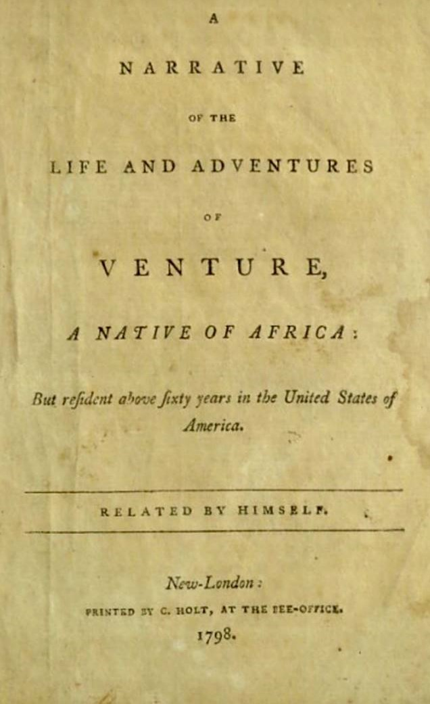
An excerpt from A Narrative of the Life and Adventures of Venture, a Native of Africa, but Resident Above Sixty Years in the United States of America, published 1798.

Image Source:
Library of Congress

Background
Venture Smith was a Black man kidnapped from his home in West Africa when he was a child to be enslaved in colonial America. His narrative is a rare account of slavery in colonial New England, one of only a few ever published. The autobiography is also one of very few accounts of enslaved people who told of their lives in Africa.

His narrative opens with, “I was born at Dukandarra, in Guinea, about the year 1729. My father’s name was Saungin Furro, Prince of the tribe of Dukandarra.” Venture’s enslavement in Rhode Island began in 1739. After many years, Venture was able to purchase his own freedom as well as that of his new family by working odd jobs.

Taking the last name of Smith from his third enslaver, Venture moved his family to New York and began farming. His farming enterprise was successful, and he continued to purchase adjacent property, eventually acquiring nearly 130 acres. At 69 years old, Venture Smith dictated his narrative to a local schoolmaster in 1798. He died in September 1805.

