## What is the American Dream?

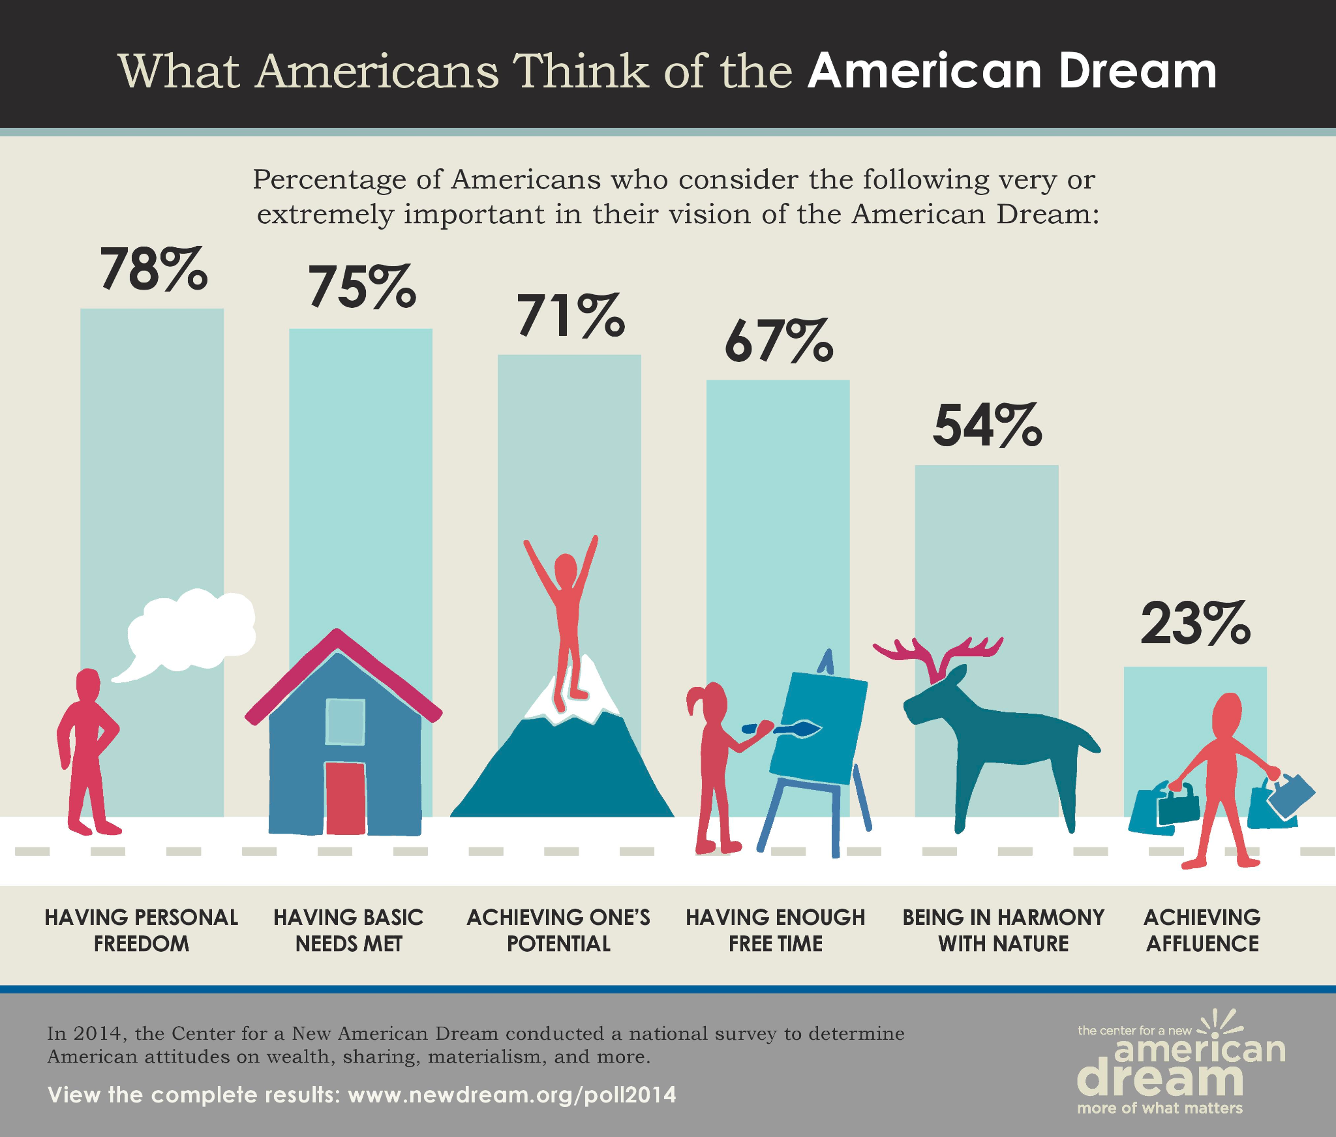

Source: [New Dream](https://newdream.org/resources/poll-2014)

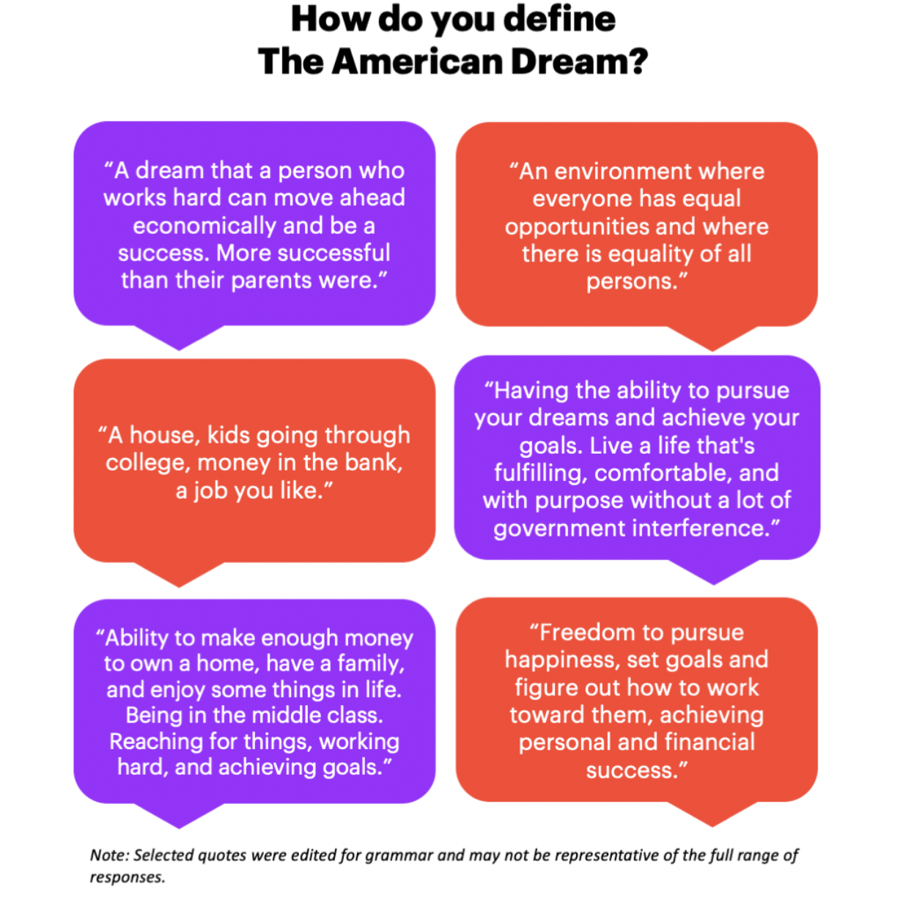

Source: [YouGov America](https://today.yougov.com/topics/politics/articles-reports/2022/07/14/do-americans-believe-american-dream)

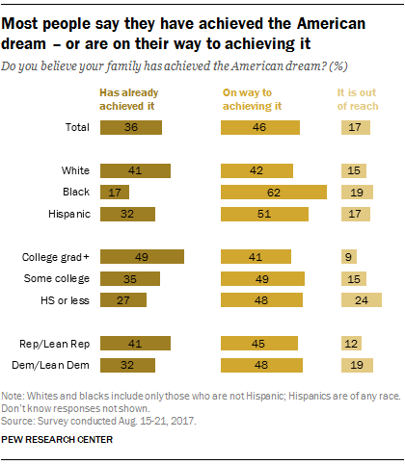

Source: [Pew Research Center](https://www.pewresearch.org/fact-tank/2017/10/31/most-think-the-american-dream-is-within-reach-for-them/ft_17-10-31_americandream_demographic/)