Practice Your Escape
Directions: Apply the ESCAPE strategy as you investigate your assigned article to determine if it is trustworthy. Capture notes from your investigation in the space provided.

Article Topic:
E | Evidence  Can you confirm the facts are true?
S | Source  Who produced it & are they trustworthy?
C | Context  Can you verify it with another trusted source?
A | Audience  Who is supposed to see, hear, or read it?
P | Purpose  Why was it created?
E | Execution  How & when was it presented?

Investigation Results
My article is:

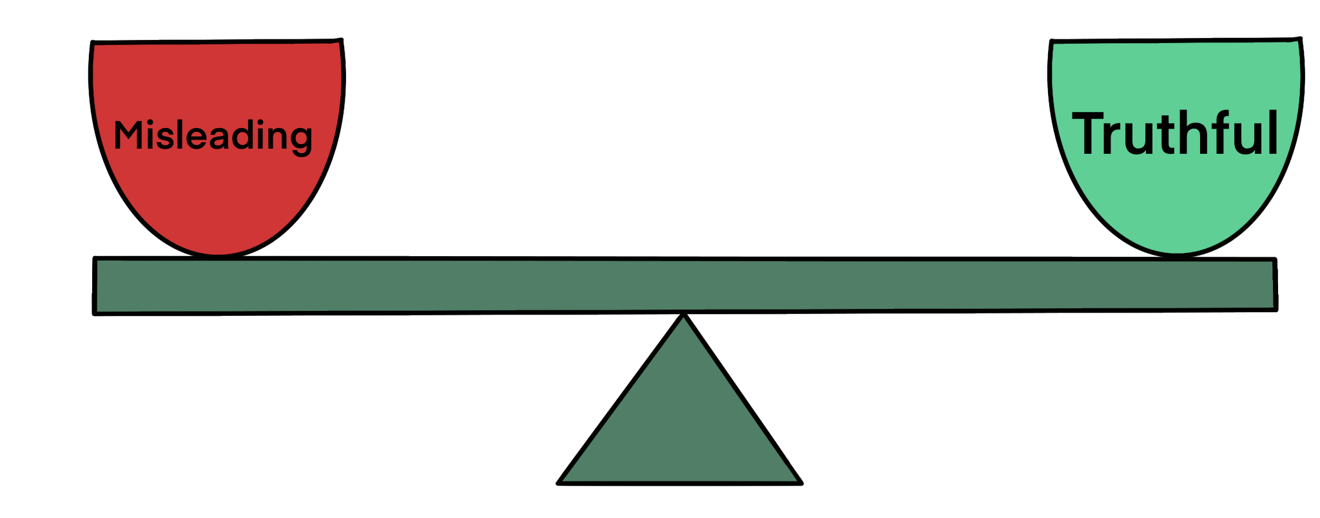
Escape Room
Determine if the source is reliable. In the box, put a T for trustworthy or a M for misinformation.
1. | 2. | 3. | 4. | 5.

