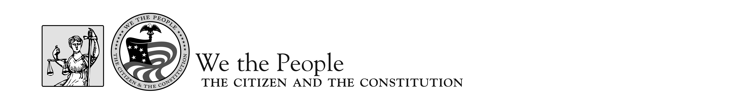

Event Schedule—National Finals 2018

FRIDAY, APRIL 27
All Day Arrivals
4:15–4:45 p.m. Facilitators’ Orientation Belmont Room- West Building
5:00–6:00 p.m. Floor Supervisors’ Orientation Belmont Room- West Building
5:00–7:00 p.m. Judges’/Facilitators’ Orientation Potomac Room- West Building
6:00–7:00 p.m. State Coordinator Meeting Belmont Room- West Building
7:00 p.m. Informal Reception- Cash Bar Black Olive- North Building

SATURDAY, APRIL 28
8:15 a.m. AM Timer/Facilitator/Judge Check in Rm. 372-North Building- 4th Floor
8:30 a.m. Judges Briefing Rm. 372-North Building- 4th Floor
9:00 a.m.–2:00 p.m. AM Competition Hearing Sessions North Building- NCC
1:30 p.m. PM Timer/Facilitator/Judge Check in Rm. 372-North Building- 4th Floor
1:45 p.m. Judges Briefing Rm. 372-North Building- 4th Floor
2:20- 7:20 p.m. PM Competition Hearing Sessions North Building- NCC

SUNDAY, APRIL 29
8:15 a.m. AM Timer/Facilitator/Judge Check in Rm. 372-North Building- 4th Floor
8:30 a.m. Judges Briefing Rm. 372-North Building- 4th Floor
9:00 a.m.–2:00 p.m. AM Competition Hearing Sessions North Building- NCC
1:30 p.m. PM Timer/Facilitator/Judge Check in Rm. 372-North Building- 4th Floor
1:45 p.m. Judges Briefing Rm. 372-North Building- 4th Floor
2:20- 7:20 p.m. PM Competition Hearing Sessions North Building- NCC

7:30 p.m.-9:30 p.m. Student Dance NCC- West Building -Ballroom
9:15 p.m. Announcement of Top Ten Finalists NCC- West Building- Ballroom
9:30 p.m. Meeting of Finalist Teachers/Coordinators NCC- West Building -Potomac

MONDAY, APRIL 30
7:00 a.m. Load coaches for Top Ten Hearings Hotel Lobby Front Door
10:00 a.m.–1:00 p.m. Competition Hearing Sessions: Finals Capitol Hill, Washington, D.C.
2:00–5:00 p.m. Competition Hearing Sessions: Finals Capitol Hill, Washington, D.C.

8:00–10:00 p.m. Awards Ceremony NCC- West Building -Ballroom

TUESDAY, MAY 1
All Day Departures

